LESSON 15 GRAVITY AND ORBITAL MOTION

Inquiry Master 15.4
Investigating the Effect of Planetary Mass on a Moon's Orbit

MATERIALS

SAfl:TY TIPS
Wear safety goggles at all times.
Do not swing the Moon Orbiter at other students. Make sure that other stu­ dents are not nearby when you swing the white sphere.
Always swing the Moon Orbiter above your head.

For you
1 pair of goggles

For your group
1 plastic box or large resealable bag containing the following:
1 pre-assembled Moon Orbiter™
25 large steel washers
1 student timer

PROCEDURE

l. Examine the Moon Orbiter™ . Discuss with your group how you think the Moon Orbiter might work.

- Move to an area in the classroom where no other groups are working . Check to see that all nylon knots are secured to the large white sphere.

- Hold the narrow plastic tubing of the Moon Orbiter in your hand like a handle. Practice holding the Moon Orbiter over your head and moving your hand in circles to get the white sphere to orbit your hand. Use a steady and regular motion. When the sphere is in full orbit, the bottom of the tube should nearly touch the cylinder.

- Increase the mass of the Moon Orbiter by adding five washers to the cylinder. Move your hand in circles over your head to get the white sphere to orbit your hand, as shown in Figure l. Describe how fast the sphere has to move to stay in orbit around your hand with a mass of five washers pulling on it. (If possible, calculate its orbital period-the time it takes the sphere to orbit your hand. For example, count the number of seconds it takes the sphere to orbit your hand 10 times. To get the orbital period, divide the number of seconds by 10.) Record your observations and data in quadrant 15.4 in your notebook.

(continued)

242 STC/MS™ EARTH IN SP ACE @ 2003 National Academy of Sciences

LESSON 15 G RA V IT Y AKO ORBITAL MOTION

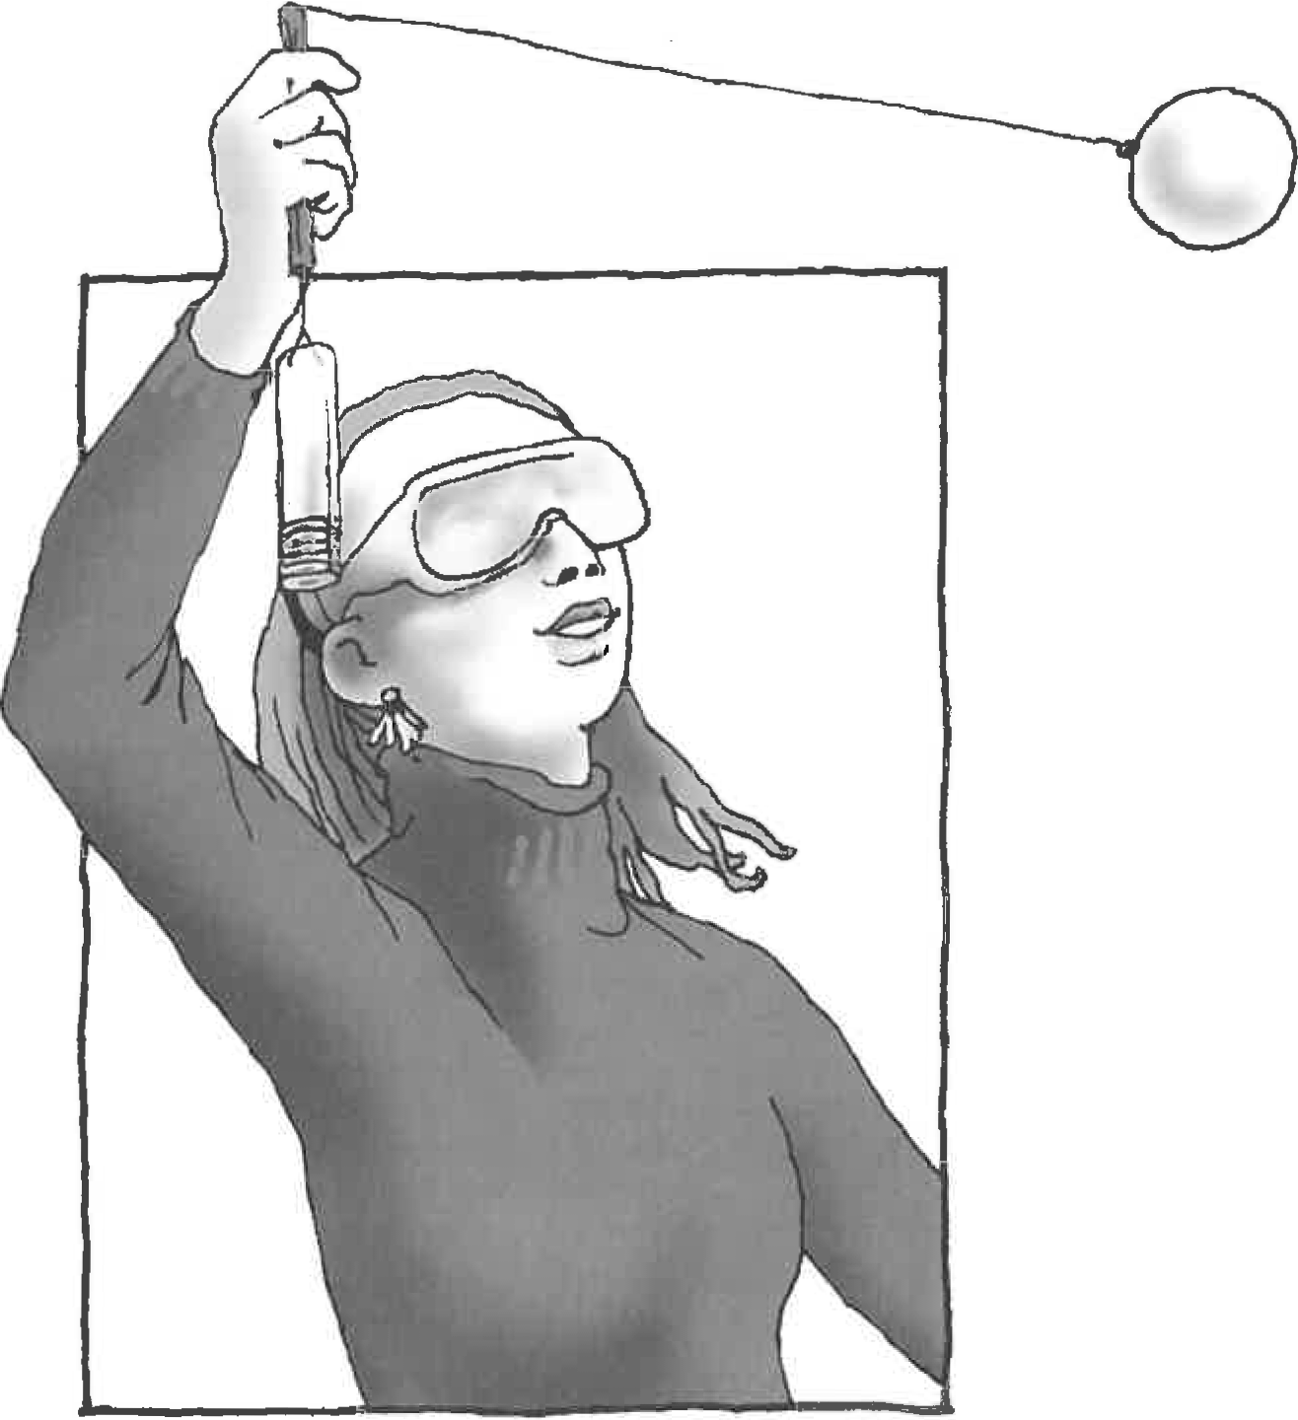
Inquiry Master 15.4 {continued)

Figure 1 Swing the white sphere in a circle above your head.

- Let everyone in your group try to swing the Moon Orbiter. Remember, when the sphere is in
full orbit, the tube should nearly touch the cylinder.

- Predict what will happen if you increase the mass of the Moon Orbiter's cylinder to 25 washers.

- Fill the cylinder of the Moon Orbiter with 25 washers. Repeat Procedure Step 4 and discuss your observations. Let everyone in your group have a turn. Describe how fast the sphere has to move to stay in orbit around your hand with 25 washers pulling on it. (Try calculating the sphere's orbital period.) Record your observations .

- Answer these questions in your notebook:

  - How does the mass of the cylinder affect how fast or slow the sphere orbits in your hand?

(continued)

I LESSON 15 G RAV I T Y AND O RBI TAL M O TI ON

Inquiry Master 15.4 (continued)

  - Examine Table 1. Compare the mass of Jupiter with the mass of Earth. \'Vh ich planet has more mass?

  - Examine Table 1. Compare Jupiter 's moon Io with Earth 's Moon. How are they alike? How are they different?

  - Compare Io and the Moon. \Vhich planetary satellite travels faster (has a greater orbital speed)? Given your results from the inquiry, why do you think this is?

  - Orbital period is the time it takes a revolving object to orbit a central object·. wh ich plane­ tary satellite has a shorter orbital period? What is the relationship bet,veen orbital speed and orbital period?

  - In Lesson 14, you learned the approximate mass of each planet. How do you think scien­ tists determine the mass of the planets?

Table 1 Planetary Mass Versus Moon's Orbital Period

Solar System Body | Approximate Mass (kg) | Diameter (km) | Distance From Planet (km) | Orbital Speed (km/sec) | Orbital Period (days)
Jupiter | 18 9,9 00 X 1022 | 142 ,984 I
' Earth | 597 X 1022 | 12,756
lo | 9 X 1022 | 3643 | 421,600 | 17 | - 2 days
Moon | 7 X 1022 | 3475 | 384,400 | 1 | - 27 days  '

- Clean up. Return all materials to their original condition.

244 STC/MS™ E A R TH I N S PAC E @ 2003 National Acad emy of Sc ienc es

