LESSON 15 GRAVITY AND ORBITAL M OTI ON

Inquiry Master 15.1
Gravity's Effect on Objects in Motion
MATERIALS

For you

SJ\fl:TY Tl PS
Wear safety goggles at all times.
Work in a well-ventilated area to
minimize the level of dust in the air.
1 pair of goggles

For your group
1 plastic box from Lesson 12
(filled with sand, flour, and cocoa)
1 large resealable plastic bag containing the following:
1 metric ruler, 30 cm (12")
1 marble
1 metric measuring tape

PROCEDURE

l. Hold the marble 40 cm above the plastic box. With the marble in your hand, decide what two forces are acting on the marble. Are the forces balanced (both pulling equally) or unbalanced (one pulling more than the other)? Discuss your ideas with your group.

- What will happen if you release the marble from your hand? Discuss your predictions with your group.

- Let go of the marble. Discuss your observations of the marble's motion with your group. (Do not be concerned about the crater that the marble makes. The sand and flour keep the marble from moving once it lands in the box.) Compare your observations to your predictions.

- Repeat Procedure Steps 1-3. Does the marble move the same way each time? Discuss your observations and record them in quadrant 15.1 in your notebook.

(continued)

LESSON 15 GRAVITY AND ORBJTAL MOTION

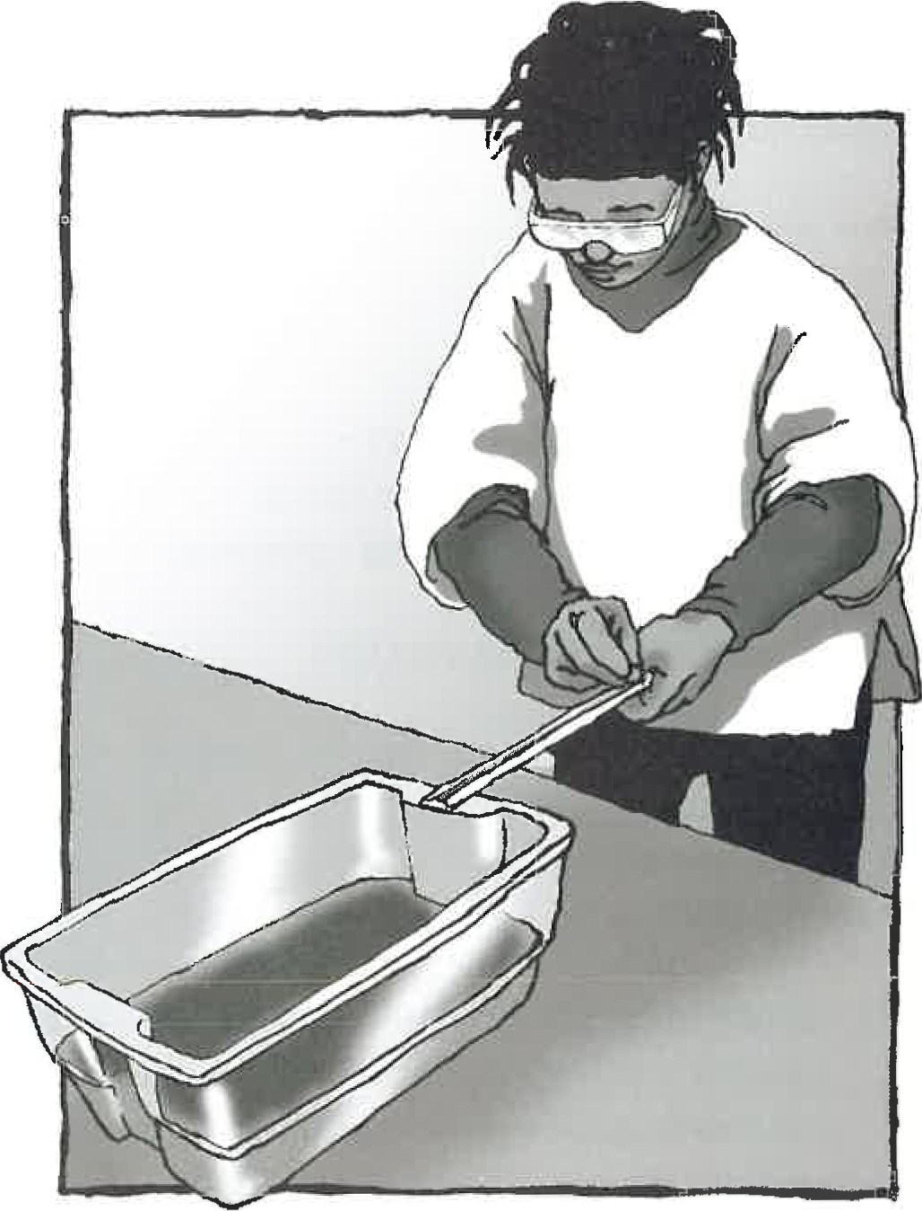
Inquiry Master 15.1 (continued)

Figure 1 Roll the marble down the ruler into the plastic box.

- use a ruler as a ramp to gently roll the marble into the plastic box, as shown in Figure 1. Keep the ruler nearly flat. Discuss your observations. How did the marble move once it left the ruler?

- Experiment by rolling the marble down the ruler at different speeds. Keep the ruler nearly flat . How does the marble move each time it leaves th e ruler? If possible, measure the distance that your marble travels each time. Record your observations in your notebook.

- Answer these questions in your notebook:

  - What pulling force acts on the marble at all times?

  - ·when you rolled the marble slowly, how did it move once it left the ruler?

  - How does the forward speed of the marble affect the motion of the marble once it leaves the ruler?

  - All planets that orbit the Sun are traveling forward due to inertia and falling toward the Sun due to gravity. Describe the path of something that has forward motion (like your marble) but is also being pulled down by gravity.

- Clean up. Return all materials to their original condition.

LESSON 15 GRAVITY AND ORBITAL MoTio:-;

@ 2003 National Acad emy of Sc ienc es

